|  |  |  |  |  |  |
| --- | --- | --- | --- | --- | --- |
| For Office Use only | | | | | |
| Date form received by pre-school : | | |  | | |
| Priority admissions  Y / N | Does your child have a sibling at South Benfleet Primary school?  Y/N | Have had a previous child at Richmond Pre-school :  Y/ N | | In catchment:    Y/ N | Wants a place from: |

**9.01b Application to join -** Richmond Pre-school CIC

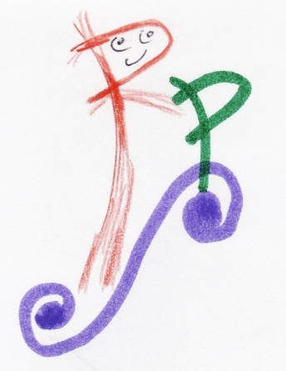c/o South Benfleet Primary School  
High Road, Benfleet, Essex, SS7 5HA  
Tel: 01268 753061

Admissions Officer: Maggie Catmull  
e-mail : [**richmondpreschool@btconnect.com**](mailto:richmondpreschool@btconnect.com)

|  |  |  |  |  |  |  |  |  |  |  |  |  |
| --- | --- | --- | --- | --- | --- | --- | --- | --- | --- | --- | --- | --- |
| **Personal details** | | | | | | | | | | | | |
| First name(s) of child: | |  | | | | | | | | | | |
| Surname of child: | |  | | | | Date of birth: | | | |  | | |
| Full address: |  | | | | | | | | | | | |
|  | | | | | | Postcode: | | |  | | | |
| Parent/carer name (1): | |  | | | | | | | | | | |
| Relationship to child: | |  | | | | | | | | | | |
| Full address (if different): | |  | | | | | | | | | | |
|  | | | | | | Postcode: | | |  | | | |
| Daytime/work tel: |  | | | Home: |  | | Mobile: | | | |  | |
| Parent (1) email : | |  | | | | | | | | | | |
| Parent/carer name (2): | |  | | | | | | | | | | |
| Relationship to child: | |  | | | | | | | | | | |
| Full address (if different): | |  | | | | | | | | | | |
|  | | | | | | Postcode: | | |  | | | |
| Daytime/work tel: |  | | | Home: |  | | Mobile: | | | |  | |
| Parent (2) email : | |  | | | | | | | | | | |
| This application places your child on our waiting list. We will contact you as soon as a suitable place becomes available.  **Session requests and other criteria**   |  |  |  | | --- | --- | --- | | Is this child a ‘Essex Child in Care’ i.e. Is the child adopted, fostered or do you have special guardianship? | |  | | Do you have a child at South Benfleet School | | Yes / No | | Do you (the adult) have any disabilities that would make travelling to other pre-schools difficult? | | Yes / No  If yes please provide professional medical evidence attached to this application. | | Do you have, or have you previously had, other children at Richmond Pre-school? | |  | | When would you ideally like your child to start? | |  | | Please note any specific sessions you need or any special requests / comments |  | |   **Please note that completion of this form does not guarantee a place for your child,**  Once your child is offered a place and you accept it, on admission further personal information and family details are required for our records. Your child’s birth certificate is required at this point with a copy made for our file and we will need to see a copy of bill/letter to verify your address.  If you decide not to accept a place when it is offer, as you wish to start your child at a later date, this may mean that you miss out on getting a place as we do not hold places open and will continue to fill up our places to ensure that the business remains viable.  Should you decide you no longer need the place, please inform us as soon as possible, we will not retain the details on this application form (see our Privacy Notice). | | | | | | | | | | | | |
| Signed parent/carer (1): | | |  | | | | | Date: | | | |  |
| Signed parent/carer (2): | | |  | | | | | Date: | | | |  |
| **Please be advised that this application form and offer of a place is subject to our terms and conditions provided to you. By signing this document, you acknowledge that you have read, understood and agree to these terms and conditions.** | | | | | | | | | | | | |